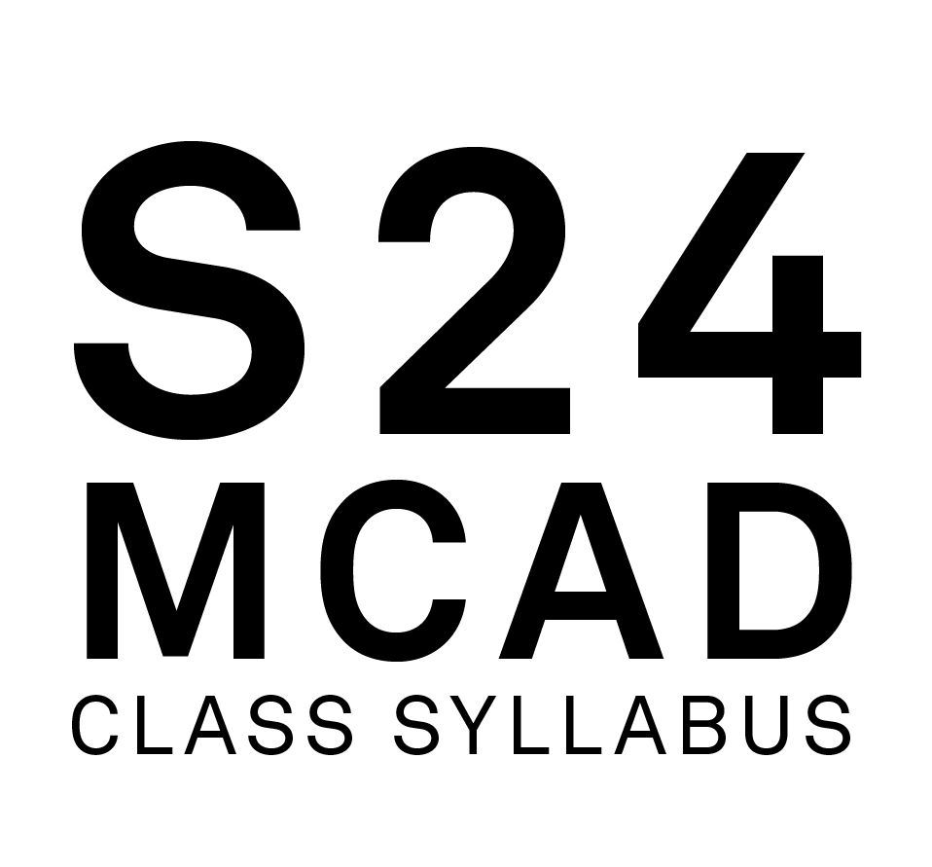

**Course Name:** Programming for Web

**Course Number:** GWD 6620 20

**Class Meets:** T,

7:00 PM - 8:30 PM,

01/16/24 - 05/07/24

**Class Google Meet Link:** https://meet.google.com/txq-wcue-ziy

**Faculty Name:** Korth, Kenneth

**MCAD Email Address:** kkorth@mcad.edu

**MCAD Telephone Number, Academic Affairs:** 612-874-3694

**Online Office Hours:** Saturdays 9am - 10 am CST

**Office Google Meet Link:** https://meet.google.com/coh-ywnv-udz

**FACULTY BIOGRAPHY:**

Ken Korth (MFA/University of Minnesota) is a web developer, web designer, and instructor specializing in front-end development. Ken has been working as a software engineer for the last 11 years and is currently working as a front-end developer for SPS Commerce in Minneapolis. Prior to pursuing his work as a front-end developer, Ken taught web development and design full-time at various colleges around the Twin Cities area. Ken has way too many hobbies to mention, but mostly he likes to spend his free time spending time with his family.

**COURSE DESCRIPTION:**

This course introduces the fundamentals of programming using the language of the web, JavaScript. Students explore topics through a variety of projects, including creating interactive web components and building a simple web application. The course progresses towards a student-selected final programming project. Topics include program and data structures, objects and arrays, functions, bugs and error handling, the Document Object Model (DOM), event handling, drawing using HTML5 canvas, data fetching, and using common libraries and tools.

**OUTCOMES:**

Apply algorithmic reasoning and programming fundamentals to solve a variety of computational problems.  
   
 Examine, critique, and improve code quality based on factors such as efficacy, reliability, maintainability, efficiency, and elegance.  
   
 Create an interactive project in JavaScript that explores the medium of code, computation, and the web.  
   
 Create an interactive web application according to design specs.  
   
 Research the landscape of JavaScript libraries, identifying those which may be useful in current or future projects.  
   
 Review concepts in Web Development: HTML and CSS.

**METHODOLOGIES:**

Lectures, Demonstrations, Readings, Class Exercises, Online Chat, 1:1 Virtual Meetings, Individual Projects, Quizzes/Tests/Exams, Individual/Class Critiques

**REQUIRED TEXTBOOKS. READINGS AND WEBSITES:**

[You Don’t Know JS](https://github.com/getify/You-Dont-Know-JS/tree/1st-ed) (online resource, no need to purchase)

Optional textbook:

[Form + Code in Design, Art, and Architecture](https://www.amazon.com/Form-Code-Design-Architecture-Briefs/dp/1568989377/ref=as_li_ss_tl?keywords=isbn+9781568989372&qid=1572629977&s=books&sr=1-1&linkCode=sl1&tag=minneapcolleg-20&linkId=ccee45a85d4dded57120c3783f5ca8be&language=en_US)

**LIBRARY RESERVE INFORMATION:**

**MATERIALS AND TOOLS LIST:**

A computer with a recent version of MacOS or Windows.  
A modern browser such as Chrome or Firefox.   
Microphone, Camera, and Headphones  
Code Editor such as VS Code.  
SFTP Client such as Transmit, Cyberduck, or Filezilla

**CANVAS:**

https://mcad.instructure.com/courses/4477

**Weekly Assignments**:

Each week has a similar rhythm. All deadlines are 11:59pm (Central).

| TUESDAY | THURSDAY | SUNDAY |
| --- | --- | --- |
| **VIDEO Week intro/review**  1 per week  Demos, discussion, feedback and critique of work. | **Exercises**  10 pts each • 2-3 per week  Coding challenges at the end of each lesson. | **Assignment**  50 pts each • 1 per week  Weekly project where you make something with code. |

**MISCELLANEOUS:**

**COURSE CALENDAR:**

 Please See Canvas Calendar for Due Dates

**Part 1: The Fundamentals of Programming**  
  
Week 1: Getting Started with JavaScript  
What is JS? What does it do? Development environment, <script>, syntax and conventions, variables, conditionals (if/then), data types, console.log, debugging, using functions   
  
Week 2: Objects and Arrays  
Ordering, selecting and displaying data from collections.  
  
Week 3: Functions and Loops  
Ways to reuse data and actions.  
  
Week 4: Capturing and reacting to Events in p5.js  
synthesis project  
  
Week 5: State Machines and Classes  
continue synthesis project  
  
  
**Part 2: Creating Interactive Web Pages**  
  
Week 6: JavaScript libraries and component thinking (React Introduction)  
  
Week 7: Style and looping in React  
  
Week 8: State and Events  
  
Week 9: Working with user input  
  
Week 10: Consuming and displaying JSON data  
  
  
**Part 3: Creative Coding**  
  
Week 11: Computational Aesthetics and Visual Representations of Time  
  
Week 12: Semantic Sounds  
  
Week 13: Models of the Physical World  
  
Week 14: Iteration  
  
Week 15: Final Project

**EMAIL USAGE:**

Email is used at MCAD as the official means of communicating with the student body. Official college announcements regarding policy, classes, registration, deadlines, etc. are delivered via email. Students are expected to check their MCAD email frequently and are held responsible for all official information communicated to them via the email system. Misuse or misrepresentation of official communications by students will result in disciplinary action.

**ATTENDANCE POLICY:**

**In-Person, Online Synchronous and HyFlex**

The MCAD community aims to foster engaged and meaningful learning experiences and a collaborative environment to promote academic success in all classrooms, whether Online, HyFlex or In-Person. MCAD is committed to creating a space of belonging and care so that students are supported and are able to participate fully in class. Full participation includes active engagement with course materials, the timely submission of assignments, and attendance at all class sessions.

Any absences, tardiness, or late assignments can result in the lowering of one's grade, at the discretion of the faculty. It is particularly important that students attend the first meeting of all courses whether Online, In-Person, or HyFlex; failing to attend the first class can impact your enrollment in the course and can have consequences on financial aid. Additionally, faculty can grant a seat to another student if a registered student has missed the first class session and has not communicated with the faculty to explain their absence.

For Synchronous Online and Hy-Flex courses, students should be prepared to utilize their computer’s camera and microphone functions and video platform chat feature to facilitate class engagement. Exceptions to this expectation may be arranged on an individual basis with the faculty.

In the case of extended illness or other documented circumstances that prevent a student from attending class, students must contact their faculty member in writing (via email) who will work with them to determine whether missed classes or assignments can be made up and, if so, ways to satisfy the requirements of the class. Students are responsible for obtaining and reviewing any missed class materials. Faculty members are advised to communicate with their department chair or director if a student has extended absences. Faculty will not reteach a class a student has missed.

**Online Asynchronous**

Students enrolled in Online Asynchronous courses are expected to engage with course materials and participate in course activities each week of the course in accordance with posted deadlines. Engagement may include group or individual activities, discussion board posts, quizzes/tests, assignments, or any combination thereof, or others as defined by the professor. Any week with no evidence of engagement in the Online Asynchronous course may result in a lowering of your grade for this course.

It is particularly important that students login and engage with their course the first week of all Online Asynchronous classes; failing to login and engage during the first week of class can impact your enrollment in the course and can have consequences on financial aid. Additionally, faculty can grant a seat to another student if a registered student has not logged into class during the first week and has not communicated with the faculty to explain their absence.

In the case of extended illness or other absences that may keep the student from participating in class, students must contact their faculty member to determine whether missed assignments can be made up and, if so, ways to satisfy the requirements of the class. Faculty members are advised to communicate with their department chair or director if a student has missed multiple assignments or has not been present in Canvas for an extended period. Faculty will not reteach material that a student has missed.

**GRADING POLICY:**

Grades consider student performance of assignments listed on each course syllabus, participation in class, magnitude of improvement, attendance, level of project difficulty, timeliness of project completion, compliance with class policies, and effort/dedication. + or - may be added to letter grades at the discretion of the faculty member. The MFA program employs a pass/fail grading system and does not use letter grades.

A = Excellent work, progress far beyond expectations of effort and outcomes, full participation

B = Good work, course requirements completed, preparedness for more advanced study

C = Average work, course requirements completed, preparedness for more advanced study

D = Passing but below average work, some promise of improvement

F = Work not acceptable, or course requirements not completed

**GRADING PROCEDURE / CRITERIA:**

VIDEO Week intro/review  
1 per week  
Demos, discussion, feedback and critique of work.  
Exercises  
10 pts each • 2-3 per week  
Coding challenges at the end of each lesson.   
Assignment  
50 pts each • 1 per week  
Weekly project where you make something with code.

**INCOMPLETE POLICY:**

To receive a grade of Incomplete for a class a student must meet with the chair of the department or program director in which the class is taught to discuss the circumstances of the request.

**GRADE NOTIFICATION:**

Midterm grades will be posted on MyMCAD between weeks 7-10 of the semester. Final grades will be posted on MyMCAD the week following commencement.

**ARCHIVING YOUR WORK:**

Students are required to submit documentation of their work for each class, every semester. Please follow this naming convention:  LastName_FirstName_ ProjectTitle.ext. Ex: oneill_co_DrawingA1.png

The media formats should follow MCAD archiving standards, which are found at:

<http://kb.mcad.edu/index.php?category=64>

Samples should be accompanied by a Word document containing relevant information, found at: [http://kb.mcad.edu/index.php?article=166 - Text Listing](http://kb.mcad.edu/index.php?article=166#Text%20Listing)

**ACADEMIC DEFICIENCIES:**

MCAD notifies students of deficiencies in academic performance through the student alert form at any time throughout the semester. Notices are placed in student mailboxes. Students are encouraged to contact the faculty member immediately and take steps to remedy the deficiency. If a student has two or more alerts the student will be contacted by the Dean of Student Affairs. A subsequent meeting will be scheduled to help the student analyze the problem and make realistic plans to remedy the situation and succeed in school.

**CLASS RECORDINGS:**

While the college does not require the recording of virtual classes, faculty may elect to do so for a variety of reasons that may include accommodating students in different time zones or for students to revisit the materials covered. In such cases, faculty must inform students at the beginning of each recorded session. Faculty who share the recordings with students will limit file permissions to view-only so as to respect the privacy of individual students. For

instructions on how to record in Google Meet, this [brief video](https://youtu.be/oEaVap0yzrg) provides step-by-step instructions.

This information is taken from the Student Handbook. You are expected to adhere to college policy.

**A. THE LEARNING CENTER:**

The Learning Center provides interdisciplinary support for all MCAD students, including face-to-face and online tutoring, an online writing and learning lab (OWLL), small and large group workshops and in-class presentations, as well as academic accommodation services for students with disabilities. The Learning Center works with students to make them better learners and prioritizes equal access and opportunity for all students. Tutoring areas include writing, software and technical skills, time management, and study skills. For more information on the Learning Center’s Hours, instructions for how to make an appointment, and access to the MCAD OWLL, visit [learningcenter.mcad.edu](http://learningcenter.mcad.edu/) or call (612) 874-3671.

**B. NONBINARY PRONOUNS/INSTITUTIONALLY RECOGNIZED NAMES:**

MCAD strives to be an inclusive and welcoming environment for all students, alumni, faculty, and staff.  Students may designate the use of an institutionally recognized name (previously referred to as alternate or preferred name) and pronouns. The forms for institutionally recognized names and pronouns are available on my.mcad.edu and are reviewed by Records Office staff upon submission.  These forms also offer students the option of updating their email addresses via the Help Desk. Please note that the Records Office will reject any name submission that is offensive, inappropriate, misleading, or otherwise represents a use of the form in bad faith.

Institutionally recognized names and pronouns will appear on faculty rosters. Legal names will continue to be used as necessary in instances including, but not limited to, student accounts, responses to verification inquiries such as verification requests, financial aid documents, payroll, official transcripts, conduct and academic honesty records, and federal immigration documents.

Institutionally recognized names and pronouns are considered non-directory information under MCAD's FERPA policy.

Students wishing to update their records with legal name and/or gender changes will use a separate process and should contact the Records Office for more information.

**C. LINKEDINLEARNING.COM:**

Students can access a wide variety of online tutorials at Lynda.com using their MCAD login information: <https://www.linkedin.com/learning/me?u=56747417>

**D. COURSE EVALUATIONS:**

Course evaluations are an integral part of MCAD curriculum development. Student feedback on courses are instrumental in creating a vibrant, informed, and robust learning community at MCAD. For these, and many other reasons, students are encouraged at the end of the semester to provide extensive feedback on course evaluations.

**E. CELL PHONE POLICY (optional):**

Cell phones should be put on mute or vibrate during class. Calls can be made during breaks, as well as before or after class.

**F. CREDIT HOUR DEFINITION:**

In lecture/discussion courses requiring outside preparation, 1 hour of credit represents 50 minutes contact time each week in class, and 2 hours of work outside of class. Therefore, a 3-credit lecture course requires 2.5 hours in class per week and approximately 6 hours outside of class.

In studio/laboratory courses, 1 hour of credit requires a minimum of 1.5 hours contact hours each week in class and approximately 1.5 hours of work outside of class. Therefore, a 3-credit studio course represents a minimum of 4.5 contact hours in class and approximately 4.5 hours of work outside of class per week.

In online courses, 1 hour of credit requires approximately 3 hours of work per week for all activities (i.e., reading, viewing, making, scanning, responding to discussion threads, collaborating, etc.). Therefore, a 3-credit online course requires approximately 9 hours per week to complete the necessary activities.

**G. CLASSROOM DEVICE USAGE POLICY:**

Participation in a classroom community has many benefits, but students will also find that along with those benefits come responsibilities:

+ Students are responsible for bringing laptops to class when scheduled to do so.

+ Student laptops should be in good working condition. If a student is experiencing problems with a laptop, it is the student’s responsibility to go to the Help Desk for help: <https://intranet.mcad.edu/department/help-desk>. Technical difficulties such as problems printing, uploading, saving, or retrieving files do not excuse late or missing work.

+ During classroom discussion, demonstration, or lecture, students should not be connected to network resources unless students are specifically instructed to do so.

+ Chatting, using social media, or emailing is no more acceptable than talking on a cell phone during class time. Non-class related use of a laptop during class time, including working on homework for other courses, may result in restriction of laptop use or a grade penalty.

+ Unless otherwise indicated, students should never use headphones during class time.

+ Students should always store copies of files in two backup locations. Students should never store the only copy of a paper/project on the student server space in case the server is down, and students are unable to access the paper/project.

+ Recording by instructor permission only. See the MCAD Student Handbook for the full policy.

**H. ACADEMIC INTEGRITY / SCHOLASTIC DISHONESTY:**

Students are prohibited from engaging in academic dishonesty. Academic dishonesty includes submission of false records of academic achievement; cheating on assignments or examinations; altering, forging or misusing a College academic record, document or funds; taking, acquiring or using test materials without faculty permission; acting alone or in cooperation with another to falsify records to obtain grades, honors, awards or professional endorsement in a dishonest manner; plagiarizing.

**Plagiarizing**

Plagiarism includes quoting uncited materials, visual, written, or coded; presenting the work of others as your own; using work of other MCAD students without their express permission. This includes submission of work for MCAD courses, exhibitions, or sales.

**Using the Same Assignment in Different Courses**

Studio projects are assigned and assessed according to the specific learning objectives and learning outcomes for each course. Occasionally students may be assigned a project in one course that shares many of the learning objectives of an assignment given in a different course. While turning in the same assignment for two courses is not encouraged, students who wish to do so are required to first notify the faculty member of each course and get permission. Faculty may assign additional requirements. Failure to notify faculty can result in failure of the assignments in both courses.

Consequences for plagiarizing, double submissions, other unauthorized or unattributed use of another’s work, and/or violations of ethical standards established by the faculty member teaching the course may include removal of work from critique, exhibition or sale, failing the assignment or the course, and/or academic probation. These policies also apply to work submitted to the MCAD Art Sale, MCAD Auction, and MCAD off-campus exhibitions. All submitted work should not infringe on another artist’s work.

**Use of Artificial Intelligence (AI) in the Production of Works**

MCAD supports students in the development of an individual voice through their work, and faculty expect student work to be a reflection of their own ideas and skill. The use of AI technology as a substitute for individual effort is strictly prohibited and will result in failing the assignment or the course, and/or academic probation. With regard to AI, unless permitted in advance by faculty to experiment with such technology, or with faculty agreement that it is applicable within the context of a larger project and properly cited as such, there will be no exception to this policy.

**I. ACCESSIBILITY AND EQUAL ACCESS:**

Persons with disabilities have a right to equal opportunity as prescribed by law. MCAD is responsible for creating a barrier-free environment while empowering students to grow toward independence and self-assertion. It is the individual student’s responsibility to make their needs known and request accommodation. First-time disclosures must be made via appointment with the Learning Center or via our Disability Disclosure Form. For more information, visit [learningcenter.mcad.edu](http://learningcenter.mcad.edu/) or call (612) 874-3671.